FAO Heritage Pentagon Exhibit Completes Long-time Association Charter Milestone
Written by Jeff Hoffmann, FAOA Board Member and FAO Heritage Pentagon Exhibit Chair

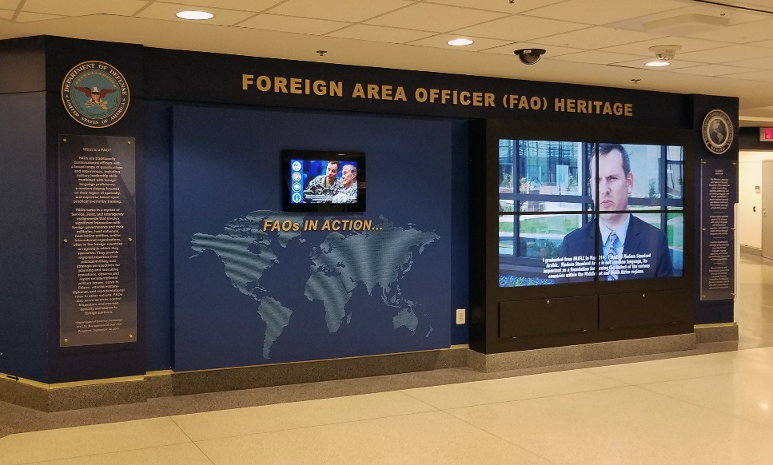
Following the official ground-breaking in December 2016, over the past month, the construction of a video wall completed the multi-year $120K FAO Heritage Pentagon Exhibit. For the ground-breaking, Former Principal Deputy Assistant Secretary of Defense for Readiness led the activities along with lead Office of Secretary of Defense (OSD) sponsors, the Defense Language and National Security Education Office (DLNSEO) and OSD Historical Exhibits and Executive Services Division. The ceremony was also attended by several leaders, members, and supporters across the FAO Community. Full details are available on FAOA website at: www.faoa.org

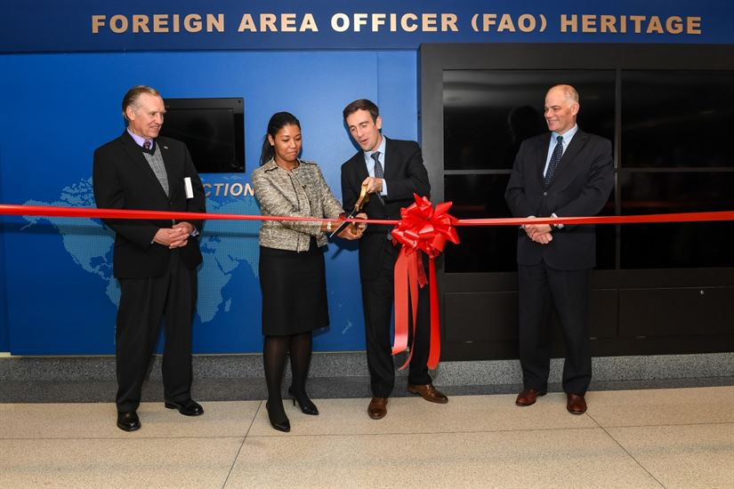
From left, Lee Johnson, Navy senior language authority and Director of the Navy Language, Regional Expertise and Culture Office; Diana Banks, Deputy Assistant Secretary of Defense for Force Education and Training and the Defense Department’s senior language authority; Daniel P.C. Feehan, Principal Deputy Assistant Secretary of Defense for Readiness; and Michael Nugent, Director of the Defense Language and National Education Office, cut the ribbon to dedicate the foreign area officer heritage wall display at the Pentagon, Dec. 12, 2016. DoD photo.

For more details, visit Defense News article at:
www.defense.gov/News/Article/Article/1036119/pentagon-heritage-displa

Evolution and Summary of the Historical Narrative
The completion of this Exhibit located on the 2nd Floor (7/8 Corridor) fulfills a long-time FAO Association Charter goal to document the history of the FAO and establish a FAO Hall of Fame/Awards Program. To establish the roots of the FAO, our team decided to extend the reach of the historical founding, beginning with U.S. Army Captain Merriweather Lewis who was co-Commander with Captain William Clark who were asked by former U.S. President Thomas Jefferson to explore the lands west of the Mississippi River. Their mission was to conduct diplomacy with and gather information about various nations of American Indians, which included contact with at least 55 different native cultural groups, including assistance from guide and interpreter Toussaint Charbonneau and his wife, Sacajawea.
Starting with Lewis and Clark paved the way for an amazing historical narrative that offered documented and archived accomplishments across the military services, not to mention several appreciative (non-monetary based) sponsors and contributors. These included the Defense Intelligence Agency, the Defense Language Institute Foreign Language Center, the George C. Marshall Center for European Center for Security Studies in Garmisch-Partenkirchen, Germany, and the George C. Marshall Foundation at the Virginia Military Institute. Additionally, several retired and active duty FAO’s contributed to the narrative including one who donated their copy of the Dayton Agreement, used by a joint U.S.-Russian team with ethnic Serbian and Bosnian units that led to separate forces during implementation of NATOs first major crisis response in Bosnia and Herzegovina. The Dayton Peace Agreement marked the end of the 1992-1995 war in the country.

Following the 1800’s, the narrative of the FAO can be linked throughout many of the historical events that helped shaped and/or worked alongside America’s national security and foreign policy. While I won’t disclose the entire Exhibit for those who are able to travel to the Pentagon to read the full history, this section of the Exhibit is divided into three timeframes:

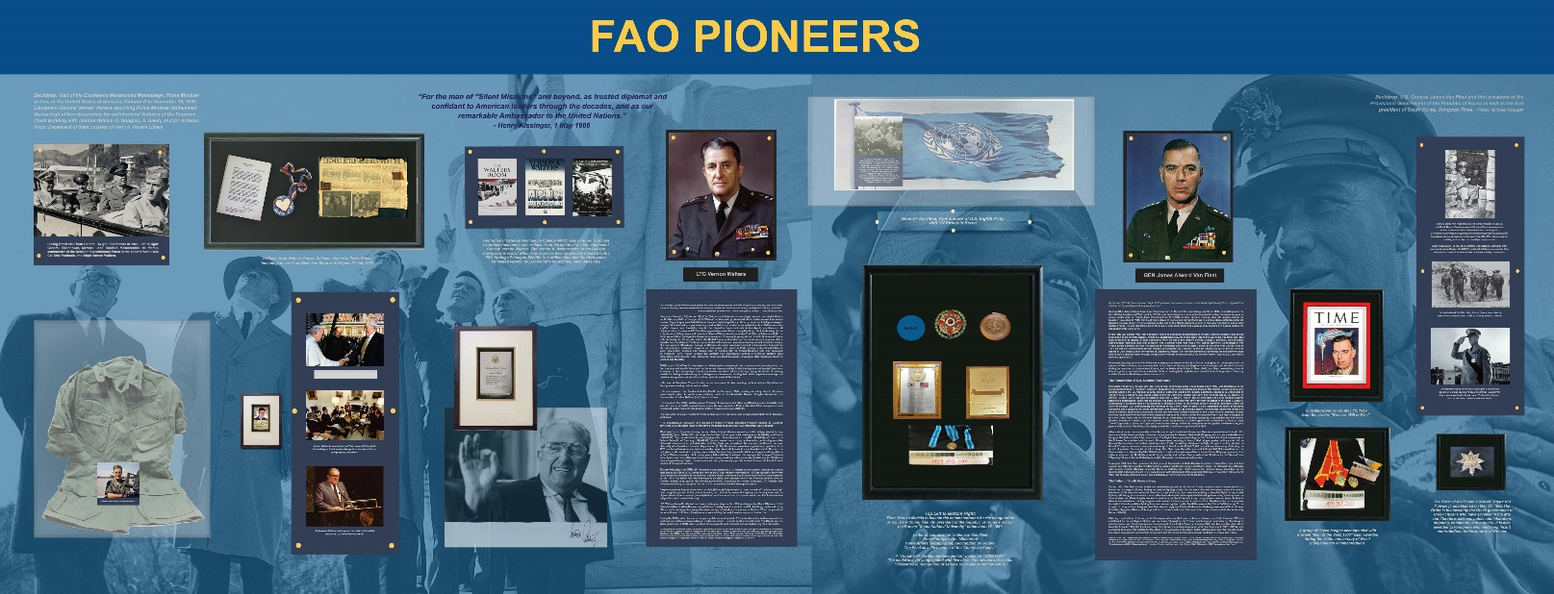
- 1920-1940 (World War). Includes historical foundation/roots of for each of the U.S. Military Service FAO lineages along with a summary of milestones that contributed to the formation of functional areas that make up the three pillars of the FAO: Security Assistance, Political-Military Affairs, and Intelligence. The leadership honored in the FAO Pioneers section began their origins during this timeframe. These two individuals are U.S. Army Lieutenant General, confidant to Dr. Henry Kissinger and U.S. Ambassador to the United Nations, Vernon Walters and former General James A. Van Fleet, known as the “Father of South Korea’s Army” and establishing foundational security assistance practices.

- 1950-1980 (The Cold War and Insurgencies). This section provides and overview of the actual terminology FAO, which originated from the U.S. Army Foreign Area Training Specialist (FAST) program and provides honorary credit to FAO Founder, recently deceased U.S. Army Lieutenant General Samuel Vaughn Wilson (AKA General Sam). General Sam was one of the first Russia FAST graduates who spent a lifetime as a soldier-statesman at the highest levels of U.S. Government including advisement to at least five U.S. Presidents (Kennedy, Johnson, Nixon, Ford, and George H.W. Bush). As a veteran Merrill’s Marauder and Fort Benning Small Units trainer for Office of Strategic Services (OSS) his experience is the true coin of counterinsurgency training, tactics, and procedures (TTP). Upon retirement, General Sam continued to consult, including assistance with the development of the Goldwater-Nichols Act of 1986 legislation known as the Nunn-Cohen Amendment that led to the establishment of the present-day U.S. Special Operations Command (USSOCOM).

- 1990-21st Century (Refining Global Partnerships). This portion paid tribute to the FAO Association (FAOA) Founder, Dr. Joseph Tulbane (U.S. Army, Eurasia FAO) including the incorporation of the Association in the Commonwealth of Virginia in January 1996. The remainder of the section defines policy and directive origins for the FAO Program along transition of the Defense Language Institute and ends with acknowledgement of the first Navy FAO Flag Officer assignment in 2010.

Other sections of the FAO Heritage Pentagon Exhibit include a tribute to the Defense Language Institute Foreign Language Center (DLIFLC) titled, “The Evolution of Foreign Language in the Armed Forces,” and artifacts memorabilia wall and the first-ever FAO Annual Awards Program and Hall of Fame.

From left, Lee Johnson, Navy senior language authority and Director of the Navy Language, Regional Expertise and Culture Office; Diana Banks, Deputy Assistant Secretary of Defense for Force Education and Training and the Defense Department’s senior language authority; Daniel P.C. Feehan, Principal Deputy Assistant Secretary of Defense for Readiness; and Michael Nugent, Director of the Defense Language and National Education Office, cut the ribbon to dedicate the foreign area officer heritage wall display at the Pentagon, Dec. 12, 2016. DoD photo.

Future Plans for the Exhibit.
The FAO Walls were designed to be evolutionary over time with the flexibility to change some portions like the Artifacts display. There is also additional wall space available for other organizations that have been approached like the Defense Security Cooperation Agency (DSCA). Most importantly, the exhibit includes a section to honor an Annual FAO Awards Program. The Video Wall including FAOs in Action allows continued update and inclusion of new material like videos, photography, and FAO event and activity updates. This exhibit will also be added to the Pentagon’s public tour circuit along with availability for special tour group requests ranging from VIP to students local universities like The Institute of World Politics and the Naval Post Graduate School Joint FAO Course.
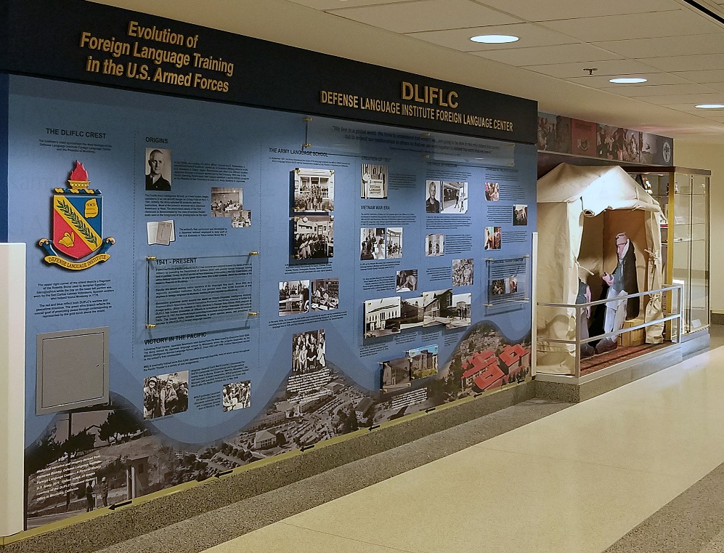
The FAO Exhibit is joined by several other Pentagon hallway displays, which you could refer to as the “Smithsonian of the Department of Defense” that allows the rich FAO history, including accomplishments and success to be displayed and shared with those who served or are serving as a FAO in addition to documenting this history and soldier-diplomat statecraft and lessons learned for future generations to come.

